**Basic Programs using BufferedReader**

**1. Find whether the given number x present in the array or not**  
Input: Array elements, number x  
Output: True or false  
*Note: Should not use ArrayList*  
  
**2. Find the Nth character in the concatenated string (concatenate given two strings)**  
Input: Str1, str2 (Two strings), number N  
Output: Nth character in resultant string  
  
  
**3. Any java program with BufferedReader that you code from scratch (even the "hello world" program, but you should code entire prog)**

**Output Screenshots:**

**1)**

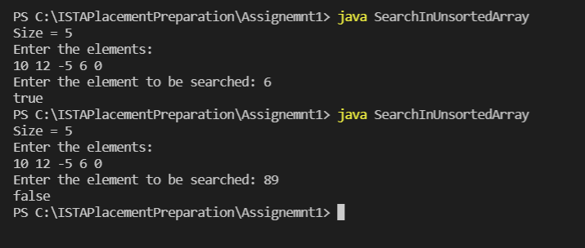

**2)** 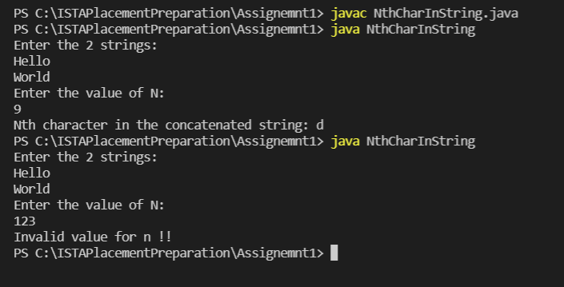

**3) Prime number check(Output)**

